# Section 6: Titles and Epithets of the Buddha

Throughout the scriptures, the Blessed One is honoured with many titles, each reflecting his incomparable wisdom, compassion, and supreme awakening. This section explores some of these profound epithets that reveal the depth of his enlightenment and the boundless impact of his teachings.

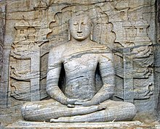

**Sitting Buddha, Gal Vihara, Sri Lanka** [1]

# The Buddha—The Awakened One

*The Pali term* ***“Buddha”*** *means* ***“the Awakened One”*** *or* ***“the Enlightened One”****—a title that signifies his perfect realization of the true nature of reality. He was known simply as* ***“the Buddha”*** *among his followers, and in the scriptures, we often see the Blessed One referring to himself by this name, embodying the essence of perfect wisdom and awakening.*

## The Buddha—Knower of Liberation, Teacher of the Path

The Buddha is revered as the one who not only attained liberation but also illuminated the path for others to follow. As he declared in the following sutta, he is called the Buddha because he realized four essential aspects of the path and guided beings toward freedom:

*“Bhikkhus, it is because of not understanding and not penetrating noble virtuous behaviour, noble concentration, noble wisdom, and noble liberation that you and I have wandered through this long cycle of existence... But now, having fully understood and penetrated these truths…”*

Then the Blessed One proclaimed:

*“Virtuous behaviour, concentration, wisdom,  
And unsurpassed liberation—  
These the illustrious Gotama  
Has realized by himself.  
Having directly known these truths,  
The Buddha teaches the Dhamma to the bhikkhus.  
He is the Teacher, the end-maker of suffering,  
The One with Vision, who has attained Nibbāna.” [2]*

## The Buddha—The Noble One Who Knows All

The term **“Buddha”** also signifies the one who possesses perfect knowledge and insight. When the Brahmin Sela inquired about enlightenment, the Buddha responded with these profound words:

*“What must be known is directly known,  
What must be developed has been developed,  
What must be abandoned has been abandoned,  
Therefore, Brahmin, I am a Buddha.”*

Deeply moved by the Blessed One’s wisdom, Brahmin Sela, with newfound confidence, proclaimed:

*“You are the Buddha, you are the Teacher,  
You are the Sage, the conqueror of Māra.  
Having cut off all evil tendencies,  
You have crossed and guide humanity across.” [3]*

## The Rare and Precious Arising of a Buddha

The birth of a Buddha in the world is an event of immeasurable significance, a beacon of hope for beings lost in the cycle of suffering. The scriptures remind us of the precious rarity of such an occurrence:

*“Difficult is it to obtain human birth,  
Challenging is the life of mortals,  
Rare it is to hear the true Dhamma,  
And rarer still is the arising of a Buddha.”* [4]

## The Buddha is a Sublime Gem

“There’s no wealth here or beyond,

no sublime gem in the heavens,

that equals the Realized One.

This sublime gem is in the Buddha:

by this truth, may you be well!” [5]

## The Buddha is the Foremost in the World

“In this world together with its devas

above, across, and below,

as far as the world extends,

the Buddha is declared foremost” [6]

## The Nature of the Buddha

“The perfect Buddhas of the past,

the Buddhas of the future,

and the present Buddha

who removes the sorrow of many:

all those dwelled, now dwell,

and in the future will dwell

revering the good Dhamma.

This is the nature of the Buddhas”[7]

## Buddha is peerless

“When, through direct knowledge,

the Buddha, the teacher, the peerless person

in this world with its devas,

sets in motion the wheel of Dhamma,

he teaches personal existence, its cessation,

the origin of personal existence,

and the noble eightfold path

that leads to the calming down of suffering” [8]

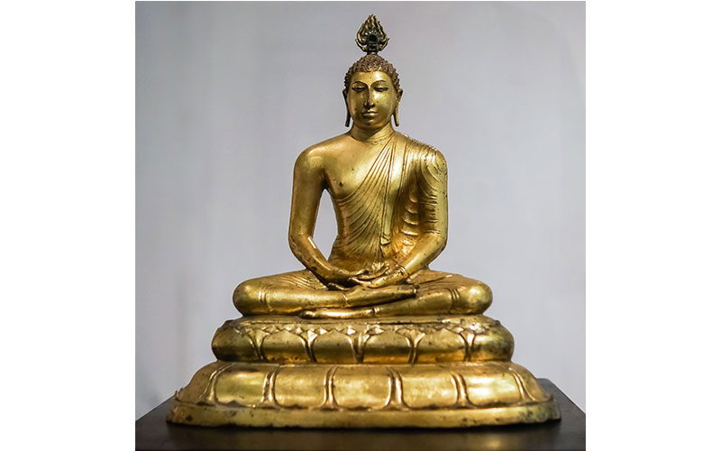

**The Buddha sitting on a lotus Flower[9]**

## The Buddha—The Noble One Unsoiled by the World

When Brahmin Dona first encountered the Blessed One, he was uncertain whether he was in the presence of a deva or a human. In his awe and curiosity, he asked the Buddha, and the Blessed One responded with these profound words: *[10]*

*“Just as a beautiful white lotus,*  *Untouched by the water, remains pure,  
So too, I am not soiled by the world.  
Therefore, O Brahmin, I am a Buddha.”*

These words express the Buddha’s transcendence over the defilements of the world, an untainted purity that arises from deep realization and mastery over the cycle of existence.

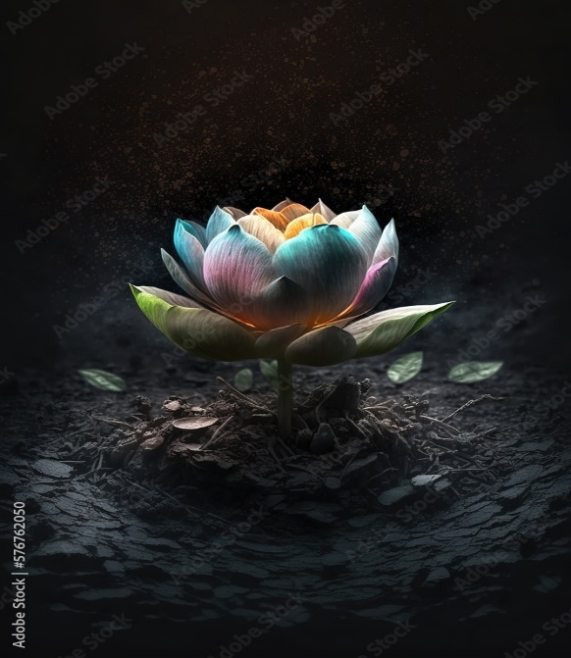

## The Buddha—Emerging Like the Lotus from the Mud of Samsāra

In the Sutta Nipāta, another verse beautifully describes how the Buddha, like the lotus, emerges from the muddy waters of samsāra: *”* [11]

*“Suppose there were a blue water lily,  
Or a pink or white lotus.  
Though it sprouted and grew in the water,  
It would rise above the surface,  
Unsoiled by the water that nourished it.  
In the same way, though I was born and grew in the world,  
I live, having mastered it,  
Unsullied by the world.”*

Just as the lotus stands tall and pure above the murky waters, the Buddha transcended the limitations of the world, embodying purity, wisdom, and peace, despite his physical presence within it.

## The Buddha—Worthy of All Offerings

The Buddha is the unsurpassed field of merit, deserving of the highest reverence and offerings. As the scriptures reveal:

*“The honourable Buddha deserves the sacrificial cake;  
He is the unsurpassed field of merit,  
The receptacle of sacrifice for all the world.  
What is given to the worthy one brings great fruit.” [12]*

To offer to the Buddha is to plant seeds of immeasurable merit, for in him is the embodiment of the highest truth, a beacon that guides all beings towards liberation.

# Tathāgata—The Fully Awakened One

In the scriptures, the Buddha referred to himself, his disciples, and followers as ‘Tathāgata’, a title meaning “the Fully Awakened One.” [13] The term can be understood as “one who has thus (tatha) gone (gata)” or “one who has thus (tatha) come (agata)”, signifying a being who has transcended all delusions and has attained perfect enlightenment. The following quotes from the scriptures reveal why the Buddha is called Tathāgata.

## Tathāgata is Fully Awakened

The Buddha explained:

*“…Bhikkhus, in this world with its devas, Māra, Brahmā, and humans… whatever is seen, heard, sensed, cognized, reached, sought after, examined by the mind—all that the Tathāgata has fully awakened to; therefore, he is called Tathāgata. Whatever the Tathāgata speaks, utters, or expounds in the interval between the night when he awakens to the unsurpassed perfect enlightenment and the night when he attains final Nibbāna, all that is just so and not otherwise. Therefore, as the Tathāgata speaks, so he does; as he does, so he speaks. Since he does as he speaks and speaks as he does, therefore… in this world with its devas, the Tathāgata is the vanquisher, the unvanquished, the universal seer, the wielder of mastery; therefore, he is called Tathāgata.”* [14]

**In these words, the Buddha emphasizes his perfect realization, where nothing in the world escapes his awakened understanding, and his actions are in perfect harmony with his words.**

## Tathāgata is the Accomplished One

When the Five Ascetics [15] addressed the Buddha as "friend," the Blessed One responded:

*“Do not address the Tathāgata by name and as a ‘friend.’ The Tathāgata is the Accomplished One, the Fully Enlightened One. Listen… the Deathless has been attained.” [16]*

The Buddha’s awakening is not just an ordinary realization but the supreme attainment—the Deathless—the realization of the eternal truth beyond birth and death.

## Tathāgata Appears for the Welfare of the World

The Buddha also said:

*“…There is one person who arises in the world for the welfare of many people, for the happiness of many people, out of compassion for the world. The manifestation of this person is rare in the world—extraordinary, unique, without peer, incomparable, matchless, unrivaled, unequalled, the foremost of bipeds. The manifestation of this one person is the manifestation of great vision, great light, the realization of the fruit of true knowledge and liberation, the realization of the fruit of stream-entry, arahantship… Who is this one person? The Tathāgata, the Arahant, the Perfectly Enlightened One.” [17]*

The Buddha’s appearance in the world is a rare and extraordinary event, a beacon of compassion and wisdom for the benefit of all beings, guiding them toward liberation.

## Tathāgata—The Embodiment of Distinguishing Qualities

The following suttas beautifully expound upon the noble qualities of the Tathāgata: [18]*“Having renounced sensual pleasures, triumphant in his journey,  
He who has known the end of birth and death,  
Who has attained Nibbāna, as cool and serene as a lake,  
The Tathāgata is worthy of the sacrificial cake.  
Just as the righteous are far from the unrighteous,  
The Tathāgata stands as one of boundless wisdom,  
Untainted here and beyond—  
The Tathāgata is worthy of the sacrificial cake.”*

These verses illuminate the purity and perfection of the Tathāgata. Having transcended all attachments and delusions, the Buddha is a beacon of wisdom and peace, untouched by the fleeting world. He embodies the supreme realization of Nibbāna—utterly serene, utterly liberated.

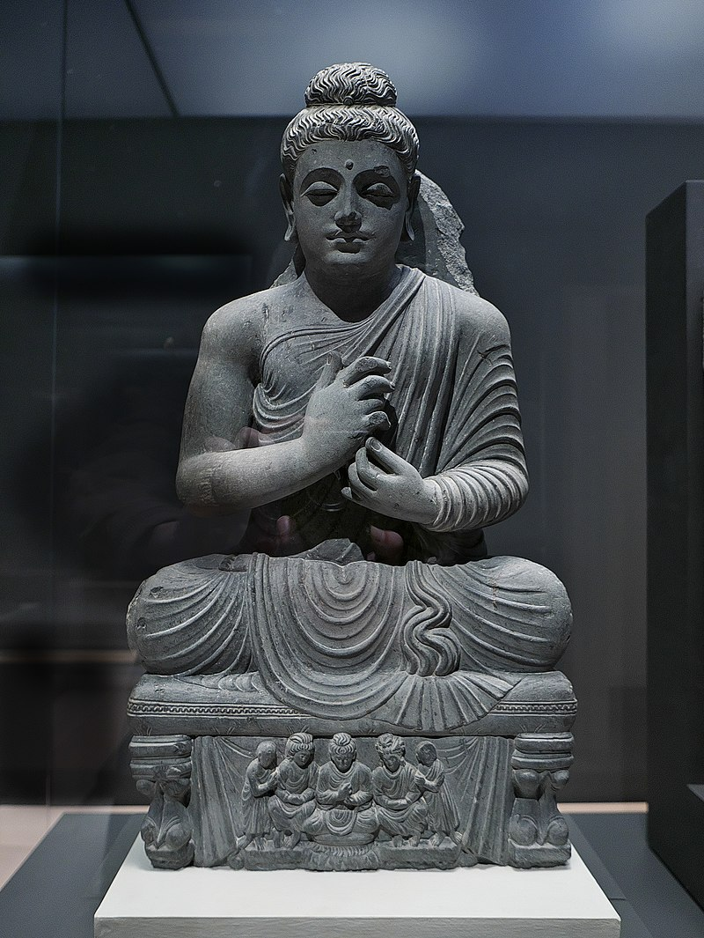

**Sitting Buddha[19]**

## The Householder Upāli Honors the Tathāgata

The householder Upāli, deeply moved by the Buddha's qualities, expressed:[20]

*“Of supreme serenity, with vast and infinite wisdom,  
A man of great wisdom, devoid of all greed,  
He is the Tathāgata, the Sublime One,  
The person unrivaled, without equal;  
He is intrepid, proficient in all,  
The Blessed One is he, and I am his disciple.”*

Upāli recognizes the Buddha as the embodiment of wisdom, serenity, and mastery, acknowledging that the Blessed One stands alone—unrivaled, incomparable, and an inspiration to all who seek the truth.

# Sammā Sambuddha—The Fully Enlightened Buddha

Among the nine noble qualities attributed to the Buddha is the title Sammā Sambuddha, meaning “he who has attained enlightenment by his own efforts.” This title reflects the Buddha’s remarkable journey of self-realization, achieved without a teacher. Through his own wisdom and determination, the Buddha rediscovered the ancient path to liberation. He then dedicated his life to sharing this path with others, teaching the Dhamma, and establishing a community of followers who continue to support and carry forward the Buddha Sasana—the dispensation of the Buddha. [21]

## Homage to the Blessed One—The Fully Enlightened One

The Buddhist world also referred to the Buddha in this way. In during their daily chanting the Buddhists, pay homage to the Blessed One like thus:

*“Namotassa Bhagavato Arahato Sammā Sambuddhassa”*

(Homage to the Blessed One, Accomplished and Fully Enlightened One)

This homage acknowledges the Buddha’s profound realization and the boundless wisdom he embodies. Let us explore the wisdom within the scriptures that explains why the Buddha is called the Fully Enlightened One.

## The Buddha as the Perfectly Enlightened One

The Buddha explained to his disciples:

*“Bhikkhus, the Tathāgata, the Arahant, the Perfectly Enlightened One, liberated by non-clinging through revulsion towards form, feeling, perception, volitional formations, and consciousness—through their fading away and cessation—is called the Perfectly Enlightened One.” [22]*

The Buddha's liberation came through the profound understanding of the impermanence of all things and his ultimate freedom from attachment and suffering. This profound realization is what defines his enlightenment.

### In the Mahāpadāna Sutta (DN: 14), the Buddha declares:

*“And, monks, in this present fortunate aeon, I too have now arisen in the world as a fully enlightened Buddha… I am now the Arahant and fully enlightened Buddha, and am of the Gotama clan.”*

Through his own efforts, the Buddha realized the supreme truth, breaking free from the cycle of birth and death to attain the highest state of enlightenment.

## King Pasenadi's Recognition of the Buddha's Enlightenment

Once, King Pasenadi of Kosala [23] approached the Buddha and asked:

*“Does Master Gotama too claim, ‘I have awakened to the unsurpassed perfect enlightenment’? [24]*

The Buddha replied:

*“I, great king, have awakened to the unsurpassed perfect enlightenment.”*

This simple yet profound affirmation from the Buddha reveals the depths of his realization—one that transcends all worldly limitations and brings liberation to all beings.

## Why the Buddha is Called Sammāsambuddha

In another sutta, the Buddha explains why he is called Sammā Sambuddha:

*“Bhikkhus, there are these Four Noble Truths. What four? The noble truth of suffering… the noble truth of the way leading to the cessation of suffering. It is because he has fully awakened to these Four Noble Truths as they really are that the Tathāgata is called the Arahant, the Perfectly Enlightened One.”* [25]

The Buddha’s perfect awakening comes from his deep understanding of the Four Noble Truths—the essence of his teaching, the path to liberation, and the cessation of all suffering.

## Noble Qualities of the Fully Enlightened Being

The scriptures also describe the Buddha’s supreme qualities:

*“He has severed craving and become the Enlightened One,  
Cleared of all fumes, completely untainted;  
Most worthy of gifts, most mighty of spirits,  
Most perfect of persons, beyond estimation;  
The greatest in grandeur, attained the peak of glory:  
The Blessed One is he, and I am his disciple.” [26]*

The Buddha is the embodiment of purity, wisdom, and compassion—his qualities are incomparable, his glory boundless.

Jina—The Victor **[27]**

The Buddha also called himself ‘Jina’, meaning “the Victor”—the conqueror who defeated Māra’s forces and won the supreme victory: the Buddhahood.

In one instance, while traveling towards Benares (Varanasi), the wandering ascetic Ājīvaka Upaka [28]saw the Buddha and asked:

*“Sir, your senses are clear and your skin is pure and bright. In whose name have you gone forth? Who is your teacher, whose teaching do you follow?”* [29]

In this moment, Upaka recognized the extraordinary radiance of the Buddha, a radiance that revealed the depth of his inner victory over all obstacles and defilements.

The Buddha replied:

*“I am the victor, the knower of all. Having abandoned everything, I am not soiled by anything. Through my own insight, I am freed by the ending of craving—so, who should I call my teacher? I have no teacher;  
No one like me exists in the world, with its gods; I have no equal.”*

**Note:**The title “Jina” is also known as “Anantajina” — Universal Victor. See: MN:26. This verse is also mentioned in the Dhammapada (Dhp:353).

## Cunda the Smith’s Son Asks About the Conqueror

On one occasion, Cunda, [30] the smith's son, asked the Buddha:

*“Whom do the Buddhas call a conqueror of the path?”*

The Buddha replied:

*“One who has crossed over perplexity, free of inner darts,  
Delighted with Nibbāna, without any greed;  
The guide of this world together with its devas:  
The Buddhas call the impartial one a conqueror of the path.” [31]*

## Devas Addressing the Buddha as Victor

Āṭānāṭiya Sutta (DN:32), we see Devas paying homage to the Buddha as Victor (Conqueror)

*“Often asked, do we revere Gotama the Conqueror? —  
We reply: ‘We do revere Gotama, great Conqueror,  
In wisdom trained, in conduct too,  
Buddha Gotama, we hail!’”*

## Disciples Addressing the Buddha as Victor

In the Therīgāthā, an elder nun recounts her struggle over twenty-five years and how, remembering the Buddha’s teachings, she found peace:

***“****In the twenty-five years since I went forth,  
I don’t know that I had ever found serenity in my mind.  
I had failed to find peace of heart,  
Or any control over my mind.  
When I remembered the victor’s instructions,  
I was struck with a sense of urgency.” [32]*

# Other Titles Attributed to the Buddha

The scriptures also mention three other titles for the Buddha: ‘Brahmin’, ‘**One bearing his last body’**, and ‘**An unsurpassed physician and surgeon’**. The Buddha spoke to the Sangha:

*“Bhikkhus, I am a Brahmin, ever accessible to entreaties, open-handed,  
One bearing his last body, an unsurpassed physician and surgeon.  
You are my legitimate sons, born from my mouth,  
Born of Dhamma, fashioned by Dhamma, heirs of Dhamma,  
Not heirs of material things.”* [33]

# Brahmin

In the scriptures the Buddha often used the word ‘**brahmin’** to referred to himself and his noble disciples who were arahants [34].

*“When things become clear to the keen, meditating brahmin, he remains, scattering Māra’s army, as the sun lights up the sky”* **[35]**

*“The brahmin who has shut out bad qualities, who is humble, free from flaws, and self-controlled, who has reached final knowledge and has fulfilled the spiritual life”[36]*

At one time a monk asked the Buddha of things make one a brahmin.

The Buddha said:

*“Those who, having removed bad things, live always mindful,  
The Buddhas who have destroyed the fetters,  
truly they are brahmanas in the world."[37]*

When a devata realizing that the Buddha has crossed over the samsara he addressed the Buddha as ‘brahmin’:

*“After a long time at last I see*

*A brahmin who is fully quenched,*

*Who by not halting, not straining,*

*Has crossed over attachment to the world”[38]*

When asked by a young deva Dāmali , the Buddha explained who a ‘brahmin’ is:

“For the brahmin there is no task to be done...

For the brahmin has done what should be done.

While he has not gained a footing in the river,

A man will strain with all his limbs;

But a footing gained, standing on the ground,

He need not strain for he has gone beyond.

This is a simile for the brahmin, O Dāmali,

For the taintless one, the discreet meditator.

Having reached the end of birth and death,

He need not strain for he has gone beyond.”[39]

# Antimadehadhari- Bearer of the Final Body

Buddha and arahants are noble beings that carry the last body and called Bearer of the Final Body—because they have destroyed all taints, therefore, no rebirth for them [40]. Following extracts from scriptures shows that the Buddha and Arahant bear the final body.

*“…a bhikkhu is an arahant, consummate, with taints destroyed, one who bears his final body…”*  [41]

*“Having known the exquisiteness of form, the origination of feelings, how perception arises, and where it disappears; having known volitional activities as alien, as suffering, and not as self—truly, that bhikkhu who sees rightly, peaceful, delights in the peaceful state. He bears his final body, having conquered Māra and his mount.” [42]*

In the *Samyutta Nikaya* (SN2:24), there is an incident where the Buddha meets Brahma Deva Ghaṭīkāra, a friend from a past life. At the end of this sutta, it is revealed that both the Buddha and Brahma Deva Ghaṭīkāra are bearers of their final bodies:

*“Such was the meeting that took place*

*Between those friends from the past,*

*both now inwardly developed,*

*Bearers of their final bodies” [43]*

### In another sutta, the Buddha affirms that he bears his final body:

*“He who is concentrated, who has crossed the flood,  
and has known the Dhamma with the supreme view,  
whose influxes are destroyed, who bears his final body:  
the Tathāgata is worthy of the sacrificial cake”[44]*

### The Buddha, having gone beyond all attachments, carries his final body:

*“One virtuous, wise, of developed mind,  
Concentrated, mindful, enjoying jhāna,  
For whom all sorrows are gone, abandoned,  
A taint-destroyer bearing his final body.” [45]*

Upali, a former follower of Nigaṇṭha Nātaputta, who became a disciple of the Buddha after hearing the Dhamma, praised the Buddha in these words:

“Free from perplexity, he abides contented,

spurning worldly gains, a vessel of gladness;

A human being who has done the recluse’s duty,

a man **who bears his final body**;

He is utterly peerless and utterly spotless:

The Blessed One is he, and I am his disciple” [46]

# An Unsurpassed Physician and Surgeon

The Buddha is also honoured with the title *Anuttaro Bhisakko Sallakatto*, the Unsurpassed Physician and Surgeon, for he cures the suffering of beings trapped in samsara with the noble medicine of the Four Noble Truths. Indeed, he is the Supreme Physician. The following sutta shows the Buddha identifying himself as such:

*“I am the one whose presence in the world*

*Is very rarely come upon,*

*I am the Fully Enlightened One,*

*I, O brahmin, am the supreme physician” [47]*

## The Buddha as the Supreme Physician

The Buddha, like a compassionate physician, offers the noble purgative known as the Eightfold Path to beings suffering from the illness of samsara, guiding them to freedom from suffering. As the scriptures reveal:

*“…bhikkhus, this is the noble purgative that always succeeds and never fails. In dependence on this path, beings subject to birth are freed from birth; beings subject to old age are freed from old age; beings subject to death are freed from death; beings subject to sorrow, lamentation, pain, dejection, and anguish are freed from sorrow, lamentation, pain, dejection, and anguish.”* [48]

## The Buddha’s Healing Power

The following extracts from the scriptures demonstrate how the Buddha, as a spiritual physician, cures beings from the malady of worldly life:

Telakāni Bhikkhu expresses how he was relieved from the poison of samsara through the Buddha’s guidance: [49]

*“Dragging it along,  
I’m not free from grief and lamentation.  
Who will free me from bonds in the world,  
So that I may know about awakening?  
...He taught the supreme path  
For the cancelling of these.  
For a long time, it had lain within me;  
For a long time, it was fixed in me:  
The Buddha cast off the knot,  
Curing the damage of poison.”*

Ubbirī, a queen of Pasenadi Kosala, grieved for the death of her only daughter, but was healed through the Buddha’s wisdom: [50]

*“Oh! For you have plucked the arrow from me,*

*so hard to see, stuck in the heart.*

*You’ve swept away the grief for my daughter*

*in which I once was mired.*

*Today I’ve plucked the arrow,*

*I’m hungerless, quenched.*

*I go for refuge to that sage,*

*the Buddha, to his teaching, and to the Sangha.”*

Brahmin Piṅgiyānī, [51] a true follower of the Buddha, compares the Buddha’s teaching to the skilful actions of a capable physician:

*“Just as a capable physician might instantly cure one who is afflicted, sick, and gravely ill; so too, sir, whatever one hears of Master Gotama’s Dhamma—discourses, mixed prose and verse, expositions, or amazing accounts—one’s sorrow, lamentation, pain, dejection, and anguish will vanish.”* [52]

## The Buddha’s Care for the Physically Unwell

The Buddha’s compassion extended beyond the spiritual realm; he also attended to the physical well-being of those who were unwell. In the *Vinaya Pitaka*, particularly in the *Bhesajjakkhandhaka*, there is abundant evidence of the Buddha’s care for the physical comfort of beings in need. [53]

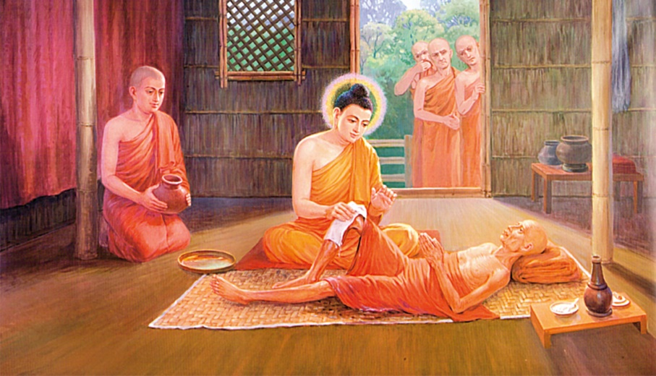

**The Blessed One attending to a sick monk[54]**

## The Buddha’s Compassionate Service: Attending to a Sick Monk

An incident from the *Vinaya Pitaka* illustrates the Buddha’s selfless service and compassionate care. The Buddha set an example for others by attending to a sick monk who had been abandoned by the rest of the community. *”[55]*

On one occasion, a monk suffering from dysentery lay in his own feces and urine. As the Buddha walked through the dwellings with Venerable Ānanda, he arrived at the sick monk’s dwelling. Upon seeing his condition, the Buddha approached and asked:

*“What’s your illness, monk?”  
“I have dysentery, Sir.”  
“But don’t you have a nurse?”  
“No.”  
“Why don’t the monks nurse you?”  
“Because I don’t do anything for them.”*

Moved with compassion, the Buddha said to Ānanda, “Go and fetch some water, Ānanda. Let us give him a wash.” After washing the sick monk and changing his robes, the monk, named Tissa [56], felt comforted and happy. Standing near him, the Blessed One, knowing that monk Tissa was about to die and had the ability to break through, spoke:

**“**Monk, consciousness will depart from you, and your body will become useless, lying on the ground like a log.”  
*(Ciraṃ vatayaṃ kāyo paṭhaviṃ adhisessati,*

*chuddho apetaviññāṇo niratthaṃ'va kaliṅgaraṃ)* [57]

Upon hearing these words, monk Tissa attained arahantship and passed away soon after.

To teach the community, the Buddha remarked**:**

**“***Monks, you have no mother or father to nurse you. If you do not nurse one another, who will? Whoever would nurse me, should nurse one who is sick.” [58]*

### He further taught:

“The greatest of all gains is health; Nibbāna is the greatest bliss. The Eightfold Path is the best of paths, for it leads safely to the Deathless.”[59]

### Guidelines for Caregivers

The Buddha not only cared for sick monks but also gave detailed guidance on the qualities required for caregivers, emphasizing selflessness, mindfulness, and compassion. He outlined the following qualities for those who would attend to the sick:

1. Capable of preparing medicine
2. Knowledge of what is beneficial and harmful, with the ability to remove what is harmful and bring what is beneficial
3. Able to nurse the sick with goodwill, not for worldly gain
4. Not disgusted by the need to clean up feces, urine, spit, or vomit

Able to instruct, inspire, and gladden the sick with Dhamma teachings from time to time [60]

# Cakkhumā- The One with of Vision

‘Cakkhumā’ is a title ascribed to the Buddha, meaning the "One with Vision" or "Clear-eyed One." The Buddha is called Cakkhumā because he possesses spiritual insight into the path of liberation, seeing deeply into the nature of suffering, the path to freedom, and the realization of Nibbāna.

In the scriptures, the Buddha is described as Cakkhumā in the following ways:

### In here the Buddha reflects on his own understanding:

*“Virtuous behaviour, samādhi wisdom, and unsurpassed liberation: these things the illustrious Gotama understood by himself. Having directly known these things; the Buddha taught the Dhamma to the bhikkhus. The Teacher, the end-maker of suffering, the One with Vision, has attained nibbāna’.*

(*Iti buddho abhiññāya, dhammamakkhāsi bhikkhunaṃ; Dukkhassantakaro satthā,* ***cakkhumā*** *parinibbuto’’ti. paṭhamaṃ)[61]*

### In the Dhammapada:

“ Of paths, the eightfold is the best of truths,

the four statements; dispassion is the best of things,

and the Clear-eyed One is the best of humans.”

*(maggānaṭṭhaṅgiko seṭṭho saccānaṃ caturo padā*

*virāgo seṭṭho dhammānaṃ dvipadānaṃ ca cakkhumā) [62]*

In the Sakkapañha Sutta (**DN:21), a young Deva named Gopka addresses the Buddha as “He-Who-Sees”:**

“Each for himself must understand

That Dhamma taught by Him-Who-Sees,

And well-proclaimed. I, serving you,

Heard the Noble Ones’ good words,

And so, I’m born, a Sakka-son”

# Vesarājja-The Self-Confident One

Vesarājja’ means "One with supreme self-confidence." This epithet describes the Buddha because he possessed four types of self-confidence. The following quote from the scriptures elaborates on these four qualities:

## The Buddha’s Four Kinds of Self-Confidence

"Bhikkhus, there are these four kinds of self-confidence that the Tathāgata has, possessing which he claims the place of the chief bull, roars his lion’s roar in the assemblies, and sets in motion the Brahma wheel. [63] What four?

1. "I do not see any ground on the basis of which an ascetic or brahmin, or deva, or Māra, or Brahmā, or anyone in the world might reasonably reprove me, saying: ‘Though you claim to be perfectly enlightened, you are not fully enlightened about these things.’ Since I do not see any such ground, I dwell securely, fearless, and self-confident. *[64]*
2. "I do not see any ground on the basis of which an ascetic or brahmin, or deva, or Māra, or Brahmā, or anyone in the world might reasonably reprove me, saying: ‘Though you claim to be one whose taints are destroyed, you have not fully destroyed these taints.’ Since I do not see any such ground, I dwell securely, fearless, and self-confident.
3. "I do not see any ground on the basis of which an ascetic or brahmin, or deva, or Māra, or Brahmā, or anyone in the world might reasonably reprove me, saying: ‘These things that you have said to be obstructive are not able to obstruct one who engages in them.’ Since I do not see any such ground, I dwell securely, fearless, and self-confident.
4. "I do not see any ground on the basis of which an ascetic or brahmin, or deva, or Māra, or Brahma, or anyone in the world might reasonably reprove me, saying: ‘The Dhamma does not lead one who practices it to the complete destruction of suffering, the goal for the sake of which you teach it.’ Since I do not see any such ground, I dwell securely, fearless, and self-confident.”

## The Buddha Does Not Need to Hide Anything

The Buddha’s openness and irreproachability further solidified his self-confidence. He openly stated that there are four things about which he has no need to hide, and three things for which he is beyond reproach: *[65]*

1. Bodily behaviour: His bodily behaviour is purified.
2. Verbal behaviour: His verbal behaviour is purified.
3. Mental behaviour: His mental behaviour is purified.
4. Livelihood: His livelihood is purified.

**Note**: The four things mentioned here align with the self-confidence the Buddha holds, as detailed in the *Mahāsihanāda Sutta* (MN:12).

# Ãdicca Bandhu - Kinsman of the Sun

**‘**Ādicca Bandhu’ is a frequently used epithet for the Buddha, meaning “Kinsman of the Sun” (*Ādicca* = Sun, *bandhu* = relative). According to legend, the Buddha’s clan, the Sakyan clan, was referred to as *Ādicca bandhu*, which is why the Buddha was often addressed by this title. .[66]

## The Buddha as the Kinsman of the Sun

In the following sutta, the Buddha refers to himself as the ‘Kinsman of the Sun’:

“*Restraint and abandonment, development and protection: these four strivings were taught by the Kinsman of the Sun. By these means, an ardent bhikkhu here can attain the destruction of suffering.”* [67]

In the Suttanipāta**a seeker of Dhamma addresses the Buddha as the “Kinsman of the Sun”:**

“Great seer, I ask you, the Kinsman of the Sun, about seclusion and the state of peace.” [68]

## Disciples’ Reverence for the Buddha

The following verses from the *Theragāthā* show that the disciples of the Blessed One also referred to him as the “Kinsman of the Sun”

*“Having heard the fine words of the Buddha,*

*the Kinsman of the Sun,*

*I penetrated the subtle truth,*

*like a hair-tip with an arrow”* [69]

“*All are sons of the Blessed One—there is no rubbish here.*

*I bow to the Kinsman of the Sun, destroyer of the dart of craving.*” [70]

## Devas’ Homage to the Buddha

In the *Āṭānāṭiya Sutta* (DN:32), the Devas express their reverence to the Buddha:

**“***They, having seen the Awakened One,  
the Buddha, Kinsman of the Sun,  
From afar, do reverence him,  
who is great and fully mature.”*

# More Epithets for the Buddha

Throughout the scriptures and in tradition, we find numerous titles given to the Buddha by devas, his direct disciples, lay followers, and others who have recognized his great wisdom, universal compassion, boundless teaching skills, and supreme qualities.

## Mārisa— Venerable Sir or Lord **[71]**

According to scriptures the devas often addressed the Buddha as mārisa—venerable sir or Lord [72]. The following quotes from the scriptures illustrate how devas would address the Blessed One:

“*kathaṃ nu tvaṃ,* ***mārisa****, oghamatarī’ti*?” *[73]*

(How, dear venerable, did you cross the flood?)

“*jānasi tho thvam* ***mārisa****, sattānaṃ nimokkhaṃ pamokkhaṃ vivekaṃ?”*

(Do you know, venerable sir, emancipation, release, seclusion for beings?” [74]

## The Victor in Battle -Vijitasaṅgāmaṃ

The Blessed One is referred as ‘the Victor in Battle’ because he has triumphed over Māra’s tenfold army. [75]

Venerable Vaṅgīsa addressed the Buddha as ‘the victor in battle[76]

*“So, they attend on the victor in battle,*

*The unsurpassed caravan leader—*

*The disciples bearing the triple knowledge,*

*Who have left Death far behind”*

## Sakka and Brahmā Sahampati’s Reverence

Both *Sakka*, the lord of the Devas, and *Brahmā Sahampati* also referred to the Buddha as the “Victor in Battle”. *[77]*

“*Rise up, O hero, victor in battle!” [78]*

*O caravan leader, debt-free one, wander in the world.*

*Teach the Dhamma, O Blessed One:There will be those who will understand” [79]*

## The Buddha’s Triumph Over Māra

The following extract highlights how the Buddha became the Victor in Battle by defeating Māra. On one occasion, Māra approached the Blessed One, who was teaching in a large assembly, and said: [80]

*“Why now do you roar like a lion,*

*Confident in the assembly?*

*For there is one who’s a match for you,*

*So why think of yourself the victor?”*

The Blessed One responded:

*“The great heroes roar their lion’s roar*

*Confident in the assemblies—*

*The Tathāgatas endowed with the powers*

*Have crossed over attachment to the world*”[81]

## The Caravan Leader- *satthāvāha*

The Blessed One is called *‘Caravan Leader’* because he leads beings across the desert of samsāra on the chariot of the Noble Eightfold Path. [82]

In the following sutta, *Brahmā Sahampati* addresses the Buddha as the *Caravan Leader*:

“*Rise up, O hero, victor in battle!*

*O caravan leader, debt-free one,*

*wander in the world. Teach the Dhamma,*

*O Blessed One:*

*There will be those who will understand*.”[83]

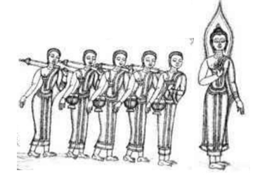

**The Buddha as a leader of a caravan showing the way to liberation**. [84]

## Aṅgīrasa- The Resplendent One

*Aṅgīrasa* (Pali) means resplendent or glorious. This epithet refers to the Buddha, as he is pure, without defilements, and shines with radiant perfection—flawless in every way.[85]

In Āṭānāṭiyasutta Sutta (DN:32), the King Vessavana, a Deva and other Devas pays homage to the Buddha calling him Aṅgīrasa:[86]

*“Glory to Angirasa, to the Sakyas’ radiant son,*

*Teacher of the Dhamma he that overcomes all suffering”*

*And when the Buddha greets their gaze,*

*Buddha, kinsman of the Sun,*

*From afar they offer homage*

*To the Lord of wisdom true:*

*“Hail, o man of noble race!*

*Hail to you, the first of men!*

*In kindness you have looked on us,*

*Who, though not human, honour you!*

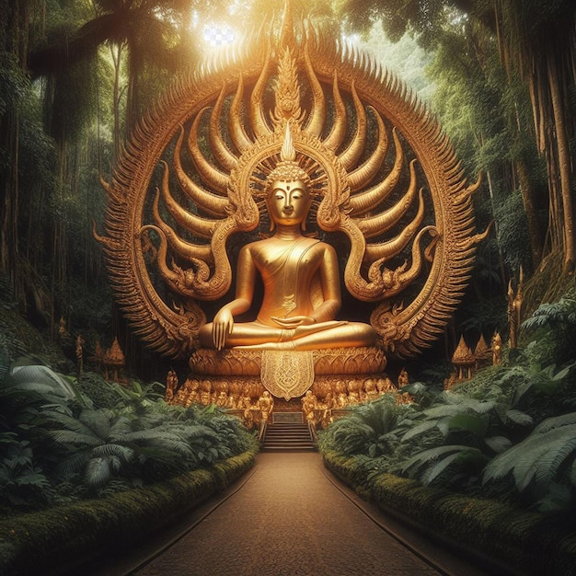

**Angirasa Buddha[87]**

### Venerable Vaṅgīsa’s Praise of the Buddha:

Venerable Vaṅgīsa, a devoted disciple of the Blessed One, expressed his admiration in these luminous verses:

*As the moon shines in a cloudless sky,  
As the sun radiates without blemish,  
So you, O Aṅgīrasa, O great sage,  
Outshine the entire world with your glory.” [88]*

*“As the moon shines in a cloudless sky,*

*As the sun shines devoid of stain,*

*So, you, Aṅgīrasa, O great sage,*

*Outshine the whole world with your glory”[89]*

### Candanaṅgalika’s Prasie

In a dialogue with five kings, led by King Pasenadi of Kosala, the Buddha's radiant presence surpassed the kings in majesty. Witnessing this, *Candanaṅgalika*, a lay follower of the Blessed One, uttered this verse: [90]

*“As the fragrant red lotus Kokanada*

*Blooms in the morning, its fragrance unspent,*

*Behold Aṅgīrasa, the Radiant One,*

*Like the sun beaming in the sky.”* [91]

***Note:*** In the *Āmbattha Sutta* (DN), the Buddha mentions *Aṅgīrasa* as one of the ten ancient Brahmin sages, revered for their wisdom and for expounding the sacred mantras. These sages—Atthaka, Vamaka, Vamadeva, Vessamitta, Yamataggi, Aṅgīrasa, Bharadvaja, Vasettha, Kassapa, and Bhagu—are respected for their profound insight. [92]

# Other Titles Bestowed Upon the Buddha

## Great Ascetic (Māha Śramaṇa)

The Buddha, having renounced his princely life to seek the ultimate truth, is often referred to as the *Great Ascetic* in the scriptures. His journey to enlightenment is an inspiration for all seekers of wisdom.

### Venerable Assaji spoke of the Buddha

*“There’s a great ascetic, a Sakyan who has gone forth from the Sakyan clan. I’ve gone forth in his name, he’s my teacher, and I follow his teaching.”* [93]

Uruvelā Kassapa, **a dreadlocked ascetic, addressed the Buddha with reverence:**

*“It’s not inconvenient for me, Great Ascetic, but there’s a fierce and highly venomous dragon king with supernormal powers there. I don’t want it to harm you.”[94]*

Brahmin householders from Magadha,seeing the Buddha with Venerable Uruvelā Kassapa, marvelled:

“*Is the Great Ascetic practicing the spiritual life under Uruvelā Kassapa, or is Uruvelā Kassapa practicing the spiritual life under the Great Ascetic?”[95]*

# Titles Given to the Buddha by Devas

One occasion revealed the Buddha's extraordinary endurance, when a stone splinter pierced his foot, causing intense bodily pain. Yet, he remained steadfast—mindful and composed, undisturbed by the discomfort. Witnessing this, a group of devas praised the Blessed One, offering these powerful epithets:

## Several Tittles Bequeathed to the Budha by Devas

On one occasion the Buddha’s foot had been cut by a stone splinter. Severe pains

assailed the Blessed One—bodily feelings that were painful, racking, sharp, piercing, harrowing, disagreeable. But the Blessed One endured them, mindful and clearly comprehending, without becoming distressed. [96] Then a group of devas visited the Buddha, having seen him enduring bodily pain with mindfulness and equanimity the group devas praised the Blessed One thus: [97]

Nāga (Elephant )**[98] :***“The ascetic Gotama is indeed a nāga... He endures bodily pain—racking, sharp, and piercing—with the unwavering composure of a nāga, mindful and clearly comprehending, without distress.”*

Sīha (Lion)**: [99]***“The ascetic Gotama is indeed a lion... When painful bodily feelings arise, he endures them with the strength and courage of a lion.”*

Nisabha (Chief Bull): **[100]** *“The ascetic Gotama is indeed the chief bull... He bears the weight of suffering as the chief bull carries its burdens.”*

Ājānīya (Thoroughbred): **[101]***“The ascetic Gotama is indeed a thoroughbred... He faces pain with the dignity and strength of a thoroughbred, unharmed and unbowed.”*

Dhorayha (Beast of Burden): **[102]***“The ascetic Gotama is indeed a beast of burden... He carries the load of suffering with the grace and endurance of one who is unshaken.”*

Danta (Tamed): **[103]  
*“****The ascetic Gotama is indeed tamed... His mind, unperturbed by pain, remains serene and untarnished.”*

Suvimuttaṃ (Well Liberated):*“The ascetic Gotama is well liberated: his samādhi is perfected, his mind unfettered—not bent forward or back, not blocked by forceful suppression.”*

***Note:*** In the *Saṁyutta Nikāya* (SN:7), a deva named *Pañcālacaṇḍa* also praises the Buddha as the “chief bull” for his unshakable equanimity

## Numerous exalted titles

In the *Upāli Sutta* (MN:56), the householder *Upāli* offers a profound homage to the Blessed One, addressing him with numerous exalted titles. Here is a glimpse of his praise: [104]

*“He is the Wise One who has cast off delusion,  
Abandoned the wilderness of the heart, victorious in battle;  
He knows no anguish, is perfectly even-minded,  
Mature in virtue, of excellent wisdom;  
Beyond all temptations, he is without stain:  
The Blessed One is he, and I am his disciple”*

*(Dhīrassa vigatamohassa, pabhinnakhīlassa vijitavijayassa; Anīghassa* *susamacittassa,* *vuddhasīlassa* *sādhupaññassa Vesamantarassa,* *vimalassa, bhagavato tassa sāvakohamasmi)*

This verse, rich in meaning, beautifully encapsulates the Buddha’s supreme qualities. Let us break down the honorifics used:

* **Wise One (Dhīrassa): The Buddha is endowed with profound wisdom, a beacon of clarity and understanding.**
* **Cast off Delusion (Vigatamohassa): He has freed himself from the delusion that clouds the minds of all beings.**
* **Abandoned the Heart’s Wilderness (Pabhinnakhīlassa): The Buddha has transcended all worldly attachments and mental obstacles, leaving behind the wilderness of craving and ignorance.**
* **Victor in Battle (Vijitavijayassa): He triumphed over Māra’s tenfold army and attained the supreme victory of Buddhahood.**
* **He Knows No Anguish (Anīghassa): Free from suffering, the Buddha has overcome all forms of mental and physical pain.**
* **Perfectly Even-Minded (Susamacittassa): He embodies perfect equanimity, unshaken by the dualities of the world.**
* **Mature in Virtue (Vuddhasīlassa): The Buddha’s virtue is mature and flawless, a model of ethical conduct for all.**
* **Excellent Wisdom (Sādhupaññassa): His wisdom shines brilliantly, cutting through ignorance and illusion.**
* **Beyond All Temptations (Vesamantarassa): He has transcended all worldly defilements and temptations, standing firm in his purity.**
* **He is Without Stain (Vimalassa): The Buddha is pure, free from any stain or corruption of the heart and mind.**

This is the end of this section. In the next section: Section:7 we will focus on the role of the Buddha as a supreme teacher of the world.

**End Notes: Section 6**

1. Source: Wikipedia https://en.wikipedia.org/wiki/Gal_Vihara
2. AN4:1 (Understood sutta).
3. **See:** MN: 92 (Sela sutta) * Similar statement is also in MN:91 (Brahmāyu sutta).
4. Dhp:14 (Translated from Pali by Bhikhu Sujato)
5. **Quote:** from Ratana sutta.
6. AN4:15.
7. AN4:21.
8. AN4:33
9. Source**:** Veheragala Buddha statue, Sri Lanka :https://www.lifie.lk/
10. AN4:36
11. Snp: 22 (Pupphasut, translated by Bhikkhu Sujato.
12. Snp:3.4 (Sundarikabhāradvāja sutta, translated by Bhikkhu Bodhi)
13. The word ‘Tathāgata’, means the same as abhisambuddha, ‘fully awakened to’. **See**: AN: Notes: 656, p.615.
14. AN:4: 23 (World sutta). * Tathāgata is also called ‘Realized One’: Iti:112 (Loka sutta: Translated by Bhikhu Sujatho).
15. The five ascetics were the attendants of the Buddha before his enlightenment; **see**: sections 4 & 4.1 for more information.
16. MN: **26 (**Ariyapariyesena sutta)
17. AN1: 170-186 (Foremost).
18. Snp:3.4 ( Sundarikabhāradvāja sutta, translated by Bhikkhu Bodhi): This is an encounter of the Buddha with brahmin Sundarikabhāradvāja, who after listening to the Buddha became established in faith, became an arahant disciple.
19. By Jl FilpoC - Own work, CC BY-SA 4.0, https://commons.wikimedia.org/w/index
20. MN:56.
21. See**:** Sections 4 & 4.1 for details.
22. See: SN22:58.
23. King Pasenadi was to become one of the Buddha’s most devoted lay followers. This sutta, it seems, records his first personal encounter with the Buddha. See: SN: Notes:199, p.530.
24. SN3:1 (Young sutta)
25. SN56: 23.
26. MN:56 (Upali sutta).
27. * Jina—Oxford Reference: A title used of the Buddhas, meaning ‘victor’.
28. He is mentioned in section 4, he became a disciple of the Buddha.
29. VP:Mahākhandaka: 5 (A translation by Bhikkhu Brahmali) * This event also mentioned in MN: 26 (Ariyapariyesena sutta).
30. He was a follower of the Buddha; he offered the last meal to the Blessed One: see: DN: 16.
31. Snp:1:5 (With the Smith Chunda), translated by Bhikkhu Bodhi.
32. Thig:3.1 (Translated by Bhikkhu Sujato).
33. Iti:100 ( Brāhmaņa dhammayāga sutta translated from Pali by John D. Ireland).
34. **\***  The Buddha uttered the first udana during his first week of enlightenment: Ud:1.3. (ttranslated from Pali by Bhikkhu Sujato . * In in VP: Mahakandha: 1: also mentioned the same utterings. * The second udana: during the 2nd week of enlightenment, a brahmin visited the Buddha and asked ‘who is a brahmin’ and the Buddha replied to him in this verse: **see:** VP: Mahākhandhaka: 2. (translation by Bhikkhu Brahmali).
35. Ibid.
36. Ibid.
37. Ud:1.5 (The discourse about the elders, translated by Bhikkhu Bodhi). * In this sutta, the Buddha having seen venerable Sāriputta, venerable Mahāmoggallāna and several other bhikkhus (who are arahants) approaching him said: ‘These brāhmaṇas are coming, monks; these brāhmaṇas are coming, monks."
38. SN1:1* Spk: The Buddha is called a *brahmin* in the sense of arahant (see Dhp 388, 396-423). He is *fully quenched* (*parinibbuto* ) in that he is quenched through the quenching of defilements (*kilesanibbānena nibbutaṃ*). Craving is designated *attachment* (*visattikā*) because it clings and adheres to a variety ofsense objects, see: SN: Notes: 4.
39. SN2: 5 (Dāmali sutta). * Spk: This young deva believed that there was no end to the

    arahant’s duties and that the arahant must continue striving even after reaching arahantship. The Buddha spoke the rejoinder to correct him. The Buddha’s verse is unique (asaṅkiṇṇā) in the Tipiṭaka, for nowhere else does the Buddha criticize the arousing of energy, but here he speaks thus to show that there is a conclusion to the arahant’s duty, see: SN:Note:147.
40. In MN: 56 (Upali sutta), the householder Upali honouring the Buddha with many titles, mentioned that the Buddha is the bearer of the last body. * In AN4: 35 ( Vassakāra sutta) there is a verse saying that the Buddha is carrying his final body.
41. SN1: 25 (The Arahant sutta). * In MN:116 (Isigili sutta) mentioned that paccekabuddha Buddhas also bearer of their final body: ‘…and twelve between—Ānandas, Nandas, and Upanandas— And Bhāradvāja bearing his last body’.
42. AN:4:16 (6) sutta
43. SN2:50 (Ghaṭīkāra sutta) * The statement that both were inwardly developed (*bhāvitattānaṃ*) and were bearing their final bodies (*sarīrantimadhārinaṃ*) implies that after his rebirth in the Pure Abodes, Ghaṭı̄kāra too had become an arahant: see: SN: Note:115.
44. Snp: 3.4 (Sundarikabhāradvāja sutta, translated by Bhikkhu Bodhi)
45. SN2:14 (Nandana sutta)
46. MN:56 (Upali sutta)
47. MN:92 (Sela sutta)
48. AN10: 108 (Physicians sutta). * AN10:109 shows how the Buddha administer noble emetic for persons to vomit the wrong view and established in right view in order to be free from all sufferings.
49. Thag:16.3 (Telakāni Thera: Verses of the Senior Monks: Translated by Bhikkhu Sujato).
50. Thig:3.5 (Ubbiri: Verses of the Senior Nuns: Translated by Bhikkhu Sujato).
51. Piṅgiyāni brahmin who was a noble disciple established in the fruit of non-returning. His daily routine was to visit the Buddha and offer him incense and garlands. After listening to him the brahmin Kāraṇapālī became a lay follower of the Buddha. **See**: AN: Notes: 1195, p. 640.
52. AN5:194.
53. “One time the monks were afflicted with autumn illness, and they could not keep down either congee or other food. As a result, they became thin, haggard, and pale, with veins protruding all over their body. The Buddha noticed this …and allowed the sick monks to take five tonics (ghee, butter, oil, honey, and syrup) both before and after midday …he also allowed medicinal roots:**(**turmeric, ginger etc. ) and plants such as nim, and other bitter leaves as medicine”. For details: **see:** VP:Bhesajjakkhandhaka: a translation of the Pali Vinaya piţaka into English by Bhikkhu Brahmali.
54. Source**:** Illustration from “The Life of the Buddha in Pictures,” Source: Dhammatalks.net
55. VP3: Cīvarakkhandhaka: 23 The account of the one who was sick, translated by Bhikkhu Brahmali.
56. Tradition says the name of the sick monk was  [Pūtigatta Tissa](https://www.wisdomlib.org/definition/putigatta-tissa#theravada)-Monk with a Stinking Body
57. Dhp:41. * The story is give in VP: Cīvarakkhandhaka 23: The account of the one who was sick: translated by by Bhikkhu Brahmali.
58. VP3: Cīvarakkhandhaka: 23 The account of the one who was sick, translated by Bhikkhu Brahmali.
59. MN:75(Māgandiya sutta)
60. VP3: Cīvarakkhandhaka: 23
61. AN4: 1 (Bhandagama sutta)
62. Dhp:273 (Translated by Bhikkhu Sujato).
63. **Brahma wheel**: referred to the wheel of the Dhamma, see: AN: Notes: 633, p.614.
64. AN4: 8 (Self-confidence sutta)
65. AN7:58 (No need to hide sutta).
66. According to Ambatta sutta (DN:3) Skyana regards King Okkāka as their ancestor. * According to the Dīpavaṃśa and the Mahāvaṃśa (ancient texts of Sri Lanka) Okkāka is the name of an ancient king from the Solar dynasty (*sūryavaṃśa*) and a descendant of Mahāsaṃmata..
67. AN4:14. * The four strivings are: by restraint, by abandonment, by development, and by protection
68. Snp:4.14 (Tuvaţaka sutta, translated by Bhikkhu Sujato).
69. Thag:16.3 ( Abhaya Thera: Verses of the Senior Monks: Translated by Bhikkhu Sujato)
70. Thag:21.1 ( Vaṅgīsa Thera: Verses of the Senior Monks: Translated by Bhikkhu Sujato)
71. *Mārisa*, as respectful term of address, something like “Sir,” pl “Sirs”, “venerable sir” (per: suttacentral) * This is the term which the devas generally use to address the Buddha, eminent bhikkhus

    (see, e.g., **40:10**; IV 270,16), and members of their own community (**11:3**; I 218,34); kings also use it to

    address one another (**3:12**; I 80,4) , Spk explains (Buddhaghosa) one without suffering (*niddukkha*), but it is probably a Middle Indic form of Skt *madṛsa*. See: SN:Note:1
72. **SN:**In Devatasamyuuta and Devaputtasamyutta there are many more suttas showing how the devas addressed the Buddha by using the title ‘mārisa’.
73. SN1.1 (Crossing the Flood sutta).
74. SN1:2 (Emancipation sutta) * Spk: Emancipation (*nimokkha*) is the path, for beings are

    emancipated from the bondage of defilements by the path; release (*pamokkha*) is the fruit, for at the moment of the fruit beings have been released from the bondage of defilements; seclusion (*viveka*) is Nibbāna, for when they attain Nibbāna beings are separated from all suffering. Or, alternatively, all three are designations for Nibbāna: for having attained Nibbāna, beings are emancipated, released, separated from all suffering”, see: SN:Note:6.
75. He has won the battle against the sensual world and freed himself. **See**: SN: Note: 517, p.568
76. SN8:7 (Pavāraṇā sutta).
77. SN11:17.
78. SN11:17.
79. SN6:1
80. SN4:12.
81. SN4:12.
82. **See:** SN: Notes: 517, p. 568.
83. SN11: 17 .
84. Source: From DN: 1 Brahmajāla Sutta, p.64. Picture courtesy: Pang Chinasai, London, 1986.
85. * The Buddha is called Aṅgīrasa because rays issue from his body (aṅgato rasmiyo nikkhamanti) * On Aṅgīrasa Malalasekera remarks (DPPN 1:20): “It is, however, well known that, according to Vedic tradition, the Gautamas belong to the Aṅgı̄rasa tribe; the word, as applied to the Buddha , therefore is probably a patronymic**.” see**: SN: Notes: 228, p.533.
86. The term angīrasa ‘radiant’ applies to all the Buddha, **see**: DN: Notes: 995, p. 467
87. Source: Picture courtesy: https://www.freepik.com/
88. SN9: 11 (Gaggara sutta),
89. SN9: 11 (Gaggara sutta),
90. SN3:12.
91. The same verse was said by brahmin Piṅgiyānī who was so inspired to see the Blessed One sitting amidst the colourful Licchavis of Vesālī. See: AN:4: 195 (5) sutta, p. 302.
92. * Ancient rishis associated with the Vedic hymns, **see:** DN: Notes: 163, p. 413. * In AN: the Buddha referred Aṅgīrasa as one of the 10 ancient seers who created Vedic hymns**, see**: 192 (2) Doṇa sutta, p. 298, see also: MN: Cankī sutta.
93. Venerable Assaji was one of the five ascetics (see section 3 & 4) who became a disciple of the Buddha. When wanderer Upatiis ( Venerable Saripuuta who became a great disciple of the Buddha) asked Venerable Assaji about his teacher, he replied thus. see: VP:Mahahandhaka: 14: a translation of the Pali Vinaya piţaka into English by Bhikkhu Brahmali.
94. This was the encounter of the Buddha with Uruvelā Kassapa at his hermitage; when the Buddha asked permission to stay for one night at his hermitage, Uruvelā Kassapa said thus. See:

    VP:Mahahandhaka: 12: a translation of the Pali Vinaya piţaka into English by Bhikkhu Brahmali.
95. This event occurred, when the Buddha after his enlightenment visited King Bimbisāra at Rajagaha. See: VP:Mahahandhaka: 13 : a translation of the Pali Vinaya piţaka into English by Bhikkhu Brahmali.
96. SN1:38 *
97. SN1:38 *
98. He is called a *nāga* on account of his strength, see: SN:Note:87.
99. He is called a *siha* on account of his frearlessness, see: SN:Note:87.
100. He is called (*nisabha*) because he is without a rival, see: SN:Note:87.
101. He is called (*ājānīya*) because he know what is right and what is wrong, see: SN:Note:87.
102. He is called (*dhorayha*) because of bearing the burden, see: SN:Note:87.
103. He is called (*danta*) because he is free from deviant conduct, see: SN:Note:87.
104. Upāli was a prominent wise and wealthy householder of Nāḷandā , who was a follower of Nigaṇṭha Nātaputta, at a later date he met the Blessed One, listened to the Dhamma and became a stream-winner. When questioned by Nigaṇṭha Nātaputta: ‘whose disciple should we consider you to be…’ Upāli uttered the verses praising the Buddha. For details: see; MN: Upāli sutta.